Core|Personnel: Bank Sort Codes

Contents
Document Version Control 1
Approved process for raising 2
Consultation & Approval 2
Change Management 2
How to 2
Testing 3
Communications 3
Downstream Systems & Processes 3
Affected Reports 3
Additional Background Information 3

Document Version Control
Change History/Review Details
Date | Version | Review by | Summary of Change
21-APR-17 | 0.1 | Simon Burford | Review draft article
05-MAY-17 | 0.2 | Helen Child | Review draft and add comments
08-MAY-17 | 0.3 | Athena Artuso | Incorporated changes and saved final version
02-JUL-19 | 0.4 | Athena Artuso | Updated the Change Management section to refer to the UOXU, UOXC and UOXP environments rather than the old V20 environments.
16-DEC-19 | 0.5 | Athena Artuso | Updated the document to reflect the new name of “CTR_Bank Sort Codes Reference Data”, which has now been changed to “PERSUP09_Bank Sort Codes Reference Data”. See change #20010691 in OSM for details.
4-Nov-22 | 0.6 | Helen Child | Updated to reflect the move of the bank maintenance screens to Portal

Approved process for raising
Does the change need to be raised through a particular route or by a particular person/team? Are there any actions which need to be taken or considered prior to processing in the HRIS Support Centre?
The list of UK bank sort codes is periodically updated by external companies, and we must incorporate these updates into our list of sort codes within CoreHR’s reference library.

We periodically receive a link to the updated list of UK sort codes in an email from helpdesk@mailservice.sortingcodeselectronic.co.uk. This email is sent to InternalServices@it.ox.ac.uk; it is then logged as an Incident in HEAT and assigned to the HRIS Analysis team for processing.

The change must be raised on HEAT and assigned to the HRIS Analysis team for processing.

Consultation & Approval
Who is the owner of this information? Who needs to be consulted about this change before you begin work on it? Does anyone need to approve this change before it is implemented?
The HRIS Analysis team “owns” this information, insofar as they are responsible for keeping it up to date within Core.

It is not necessary to keep the bank sort code list up to date every time an updated list is published as it is quite rare that a sort code is required which does not already exist within the system (and it is easy to add a new sort code manually) so approval to proceed with the change to sort codes is dependent upon resource availability within the HRIS Analyst team.

An update to the bank sort codes should be raised as a Standard Change within HEAT. Standard Changes do not require formal approval providing the process set out in this document (and any documents linked) is followed.

Change Management
What type of change is this? When should approval be sought and from whom (internal to team or change manager)? Who would normally be responsible for implementing?
Manually add/amend/remove bank sort codes
Any manual processing of bank sort codes in the system should be processed as a change in OSM, implemented by the HRIS Analysis team and approved by the Senior HRIS Analyst.

Upload new bank sort codes
The addition of new bank sort codes to Core’s “Bank Reference” reference table via the Data Migration tool in Core is implemented by the HRIS Analysis team. The section below relates only to this method of adding bank sort codes.

The change should be managed as a Standard change within OSM. To raise a Standard change for uploading new bank sort codes, the HRIS Analyst must paste the following “Details” section into the change record or copy change record #20006771, and create the “Tasks” listed below. You should also attach the file you are uploading to the Change Record.

Details
1. Details - What is changing?
==This change is an update to Core’s “Bank Reference” reference table using the Data Migration tool within CoreHR. The tool inserts new lines into the reference tables at Reference > Reference A – C > Bank Sort Codes within the Back Office using a file prepared by HRIS Analysts (see attached).

2. Justification - Why is the change necessary?
==The list of UK bank sort codes is periodically updated, and we must incorporate these updates into our list of sort codes within CoreHR’s reference library to ensure we have up-to-date information on all UK banks.

3. Related Changes - Are there dependent changes?
==No.

4. Impact on dependent services? What is the impact on connected or downstream services or components?
==There is no impact on dependent services.

5. Impact - Specify downtime or at risk period.
==No downtime or "at risk" period.

6. Impact - Effect of not applying the change?
==If we don't upload the new bank sort codes, the reference data in CoreHR will be out of date and any user attempting to enter a sort code not in CoreHR will receive an error.

7. Risk Assessment - What are the risks to the services?
==No risks to services.

8. Testing - Who will test it and how?
==The HRIS Analyst is responsible for testing each upload in a suitable test environment before migrating the data into UOXP. A small “test” upload file consisting of a few lines of data should be put through the steps above in either UOXC or UOXU, and the migration should be sense-checked. If the test migration is successful, the data can be migrated into UOXP.

9. Implementation Plan - Who will implement it and how?
==The HRIS Analyst will load the new sort codes into UOXP if the test upload was successful.

10. Communications Plan – Who needs to know and how?
==No communications are required.

11. Business Owner/Approver
==Marie Cooksey Head of HR Systems (this is a Standard change and does not require the approval of the Business Owner)

12. What is the potential security impact of the change?
=== None.

13. How will the security impact be tested?
=== N/A

14. Back Out Plan - How will it be backed out in the event of the change failing?
==If the test migration does not succeed, the change will not be implemented in UOXP. In the unlikely event of problems with any data uploaded to UOXP, the HRIS Analyst will delete the affected records by going to the "Maintain Bank Details" screen at Reference > Reference A – C > Bank Sort Codes.

Tasks

UOXU: Test upload of new sort codes into Core
Create a test file containing one line of data from the "NEW Sort Codes [DD MM YYYY]" spreadsheet, and run it through the Staff Portal > Data Migration Tool. If it passes validation checks, migrate the data into UOXU. Check that the newly-uploaded data in Core matches the data from the test file.

UOXP: Upload new sort codes into Core
Once the test in UOXU has passed and the change has been approved, use the Data Migration Tool to upload the new sort codes into UOXP. Sense-check the data within the Reference library to ensure that it matches what is in the upload file.

How to
Technically how to process the change in the system
Upload new bank sort codes
Detailed guidance on how to upload new bank sort codes is contained in the document HOW TO - Upload New Bank Sort Codes, currently contained in the following folder:

P:\PROJECTS\HRIS Programme\12. Support\Reference Data\Bank Sort Codes\HOW TO - Upload new bank sort codes.docx

Manually add a single bank sort code
To manually add a single sort code, log in to Core|Portal and navigate to Payroll Dashboard > Settings > Banking > Bank Details.

Click ADD SORT CODE

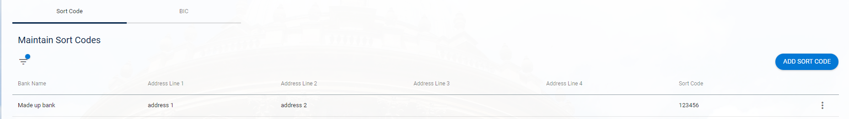

In the pop-up window enter the details:

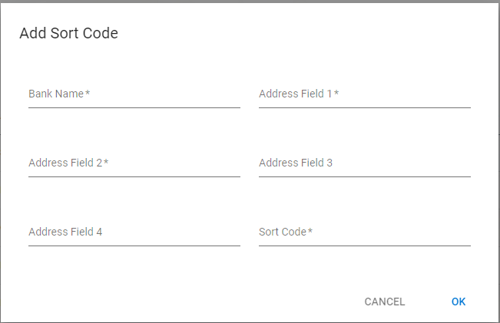

Click OK to save.

Change a bank sort code
To manually change a single sort code, log in to Core|Portal and navigate to Payroll Dashboard > Settings > Banking > Bank Details.

On the Sort Code tab, click on the filter option:

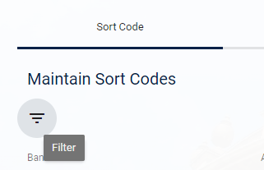

Enter search criteria and click APPLY:

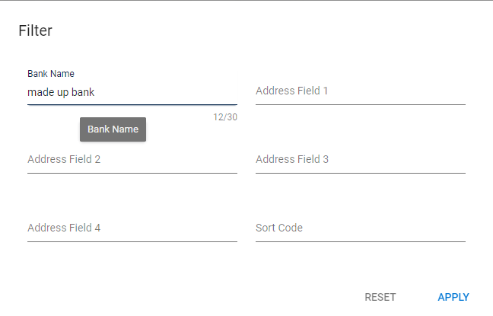

Click on the ellipses at the end of the record you wish to amend and choose Edit.

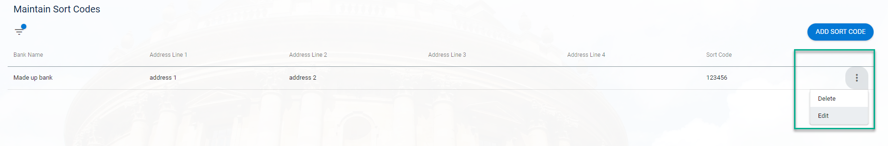

Enter the revised details and click OK to save

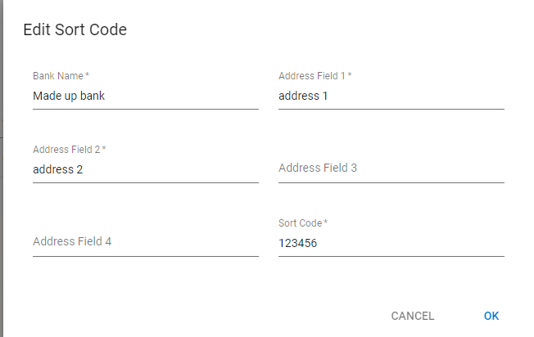

Remove a bank sort code
It is unlikely that we will need to remove a bank sort code. If the need arises, discuss with the Senior HRIS Analyst.

Testing
Who would normally be responsible for testing? Are there standard items to test?
The HRIS Analyst is responsible for testing each upload in a suitable test environment before migrating the data into UOXP. A small “test” upload file consisting of a few lines of data should be put through the steps above in either UOXC or UOXU, and the migration should be sense-checked. If the test migration is successful, the data can be migrated into UOXP.

Communications
Who needs to be informed (but not consulted) about this change? Detail when they should be informed (before or after the change).
The HRIS Support Centre service desk should be informed via incident management once the bank sort codes are updated.

Downstream Systems & Processes
Details of any processes which are affected or need to be carried out following, or as part of, the change. Please detail any triggers, actions required and when the actions should be carried out.
None

Affected Reports
Are there any standard reports which may need to be updated following this change?
The appropriate report to use when maintaining bank sort codes is “PERSUP09_Bank Sort Codes Reference Data”.

Additional Background Information
Any other relevant information, links to supporting documentation etc.
Core has supplied the user guide for the Data Migration tool (link).

